**Week - 10**

**(24 August 2023)**

**Experiment - 9**

**Question:**

1. Write a C program to simulate the following file organization techniques:
2. Single level directory

**(b)** Two level directory

**(c)** Hierarchical

**(ii)** Write a C program to simulate disk scheduling algorithms:

1. FCFS
2. SCAN
3. c-SCAN

**(iii)** Write a C program to simulate disk scheduling algorithms:

**(a)** SSTF

**(b)** LOOK

**(c)** c-LOOK

**Program:**

1. **File Organization Techniques:**
2. **Single Level Directory:**

#include<stdio.h>

#include<string.h>

#include<stdlib.h>

struct

{

char dname[10],fname[10][10];

int fcnt;

} dir;

void main()

{

int i,ch;

char f[30];

dir.fcnt = 0;

printf("\nEnter name of directory -- ");

scanf("%s", dir.dname);

while(1)

{

printf("\n\n1. Create File\t2. Delete File\t3. Search File \n4. Display Files\t5. Exit\nEnter your choice -- ");

scanf("%d",&ch);

switch(ch)

{

case 1: printf("\nEnter the name of the file -- ");

scanf("%s",dir.fname[dir.fcnt]);

dir.fcnt++;

break;

case 2: printf("\nEnter the name of the file -- ");

scanf("%s",f);

for(i=0;i<dir.fcnt;i++)

{

if(strcmp(f, dir.fname[i])==0)

{

printf("File %s is deleted ",f);

strcpy(dir.fname[i],dir.fname[dir.fcnt-1]);

break;

}

}

if(i==dir.fcnt)

printf("File %s not found",f);

else

dir.fcnt--;

break;

case 3: printf("\nEnter the name of the file -- ");

scanf("%s",f);

for(i=0;i<dir.fcnt;i++)

{

if(strcmp(f, dir.fname[i])==0)

{

printf("File %s is found ", f);

break;

}

}

if(i==dir.fcnt)

printf("File %s not found",f);

break;

case 4: if(dir.fcnt==0)

printf("\nDirectory Empty");

else

{

printf("\nThe Files are -- ");

for(i=0;i<dir.fcnt;i++)

printf("\t%s",dir.fname[i]);

}

break;

default: exit(0);

}

}

}

1. **Two Level Directory:**

#include<stdio.h>

#include<string.h>

#include<stdlib.h>

struct

{

char dname[10],fname[10][10];

int fcnt;

}dir[10];

void main()

{

int i,ch,dcnt,k;

char f[30], d[30];

dcnt=0;

while(1)

{

printf("\n1. Create Directory\t2. Create File\t3. Delete File");

printf("\n4. Search File\t\t5. Display\t6. Exit\nEnter your choice --");

scanf("%d",&ch);

switch(ch)

{

case 1: printf("\nEnter name of directory -- ");

scanf("%s", dir[dcnt].dname);

dir[dcnt].fcnt=0;

dcnt++;

printf("Directory created");

break;

case 2: printf("\nEnter name of the directory -- ");

scanf("%s",d);

for(i=0;i<dcnt;i++)

if(strcmp(d,dir[i].dname)==0)

{

printf("Enter name of the file -- ");

scanf("%s",dir[i].fname[dir[i].fcnt]);

dir[i].fcnt++;

printf("File created");

break;

}

if(i==dcnt)

printf("Directory %s not found",d);

break;

case 3: printf("\nEnter name of the directory -- ");

scanf("%s",d);

for(i=0;i<dcnt;i++)

{

if(strcmp(d,dir[i].dname)==0)

{

printf("Enter name of the file -- ");

scanf("%s",f);

for(k=0;k<dir[i].fcnt;k++)

{

if(strcmp(f, dir[i].fname[k])==0)

{

printf("File %s is deleted ",f);

dir[i].fcnt--;

strcpy(dir[i].fname[k],dir[i].fname[dir[i].fcnt]);

goto jmp;

}

}

printf("File %s not found",f);

goto jmp;

}

}

printf("Directory %s not found",d);

jmp : break;

case 4: printf("\nEnter name of the directory -- ");

scanf("%s",d);

for(i=0;i<dcnt;i++)

{

if(strcmp(d,dir[i].dname)==0)

{

printf("Enter the name of the file -- ");

scanf("%s",f);

for(k=0;k<dir[i].fcnt;k++)

{

if(strcmp(f, dir[i].fname[k])==0)

{

printf("File %s is found ",f);

goto jmp1;

}

}

printf("File %s not found",f);

goto jmp1;

}

}

printf("Directory %s not found",d);

jmp1: break;

case 5: if(dcnt==0)

printf("\nNo Directory's ");

else

{

printf("\nDirectory\tFiles");

for(i=0;i<dcnt;i++)

{

printf("\n%s\t\t",dir[i].dname);

for(k=0;k<dir[i].fcnt;k++)

printf("\t%s",dir[i].fname[k]);

}

}

break;

default:exit(0);

}

}

}

1. **Hierarchical:**

#include<stdio.h>

#include<string.h>

#include<stdlib.h>

//#include<graphics.h>

struct tree_element

{

char name[20];

int x,y,ftype,lx,rx,nc,level;

struct tree_element *link[5];

};

typedef struct tree_element node;

void main()

{

int gm;

node *root;

root=NULL;

create(&root,0,"root",0,639,320);

//initgraph(&gd,&gm,"c:\\tc\\BGI");

display(root);

//closegraph();

}

create(node **root,int lev,char *dname,int lx,int rx,int x)

{

int i,gap;

if(*root==NULL)

{

(*root)=(node *)malloc(sizeof(node));

printf("Enter name of dir/file(under %s) :",dname);

fflush(stdin);

gets((*root)->name);

printf("enter 1 for Dir/2 forfile :");

scanf("%d",&(*root)->ftype);

(*root)->level=lev;

(*root)->y=50+lev*50;

(*root)->x=x;

(*root)->lx=lx;

(*root)->rx=rx;

for(i=0;i<5;i++)

(*root)->link[i]=NULL;

if((*root)->ftype==1)

{

printf("No of sub directories/files(for %s):",(*root)->name); scanf("%d",&(*root)->nc);

if((*root)->nc==0)

gap=rx-lx;

else

gap=(rx-lx)/(*root)->nc;

for(i=0;i<(*root)->nc;i++)

create(&((*root)->link[i]),lev+1,(*root)->name,lx+gap*i,lx+gap*i+gap,lx+gap*i+gap/2);

}

else (*root)->nc=0;

}

}

/*display(node *root)

{

int i;

settextstyle(2,0,4);

settextjustify(1,1);

setfillstyle(1,BLUE);

setcolor(14);

if(root!=NULL)

{

for(i=0;i<root->nc;i++)

{

line(root->x,root->y,root->link[i]->x,root->link[i]->y);

}

if(root->ftype==1)

bar3d(root->x-20,root->y-10,root->x+20,root->y+10,0,0);

else

fillellipse(root->x,root->y,20,20);

outtextxy(root->x,root->y,root->name);

for(i=0;i<root->nc;i++)

{

display(root->link[i]);

}

}

}*/

**Output (File Organization Techniques):**

1. **Single Level Directory:**

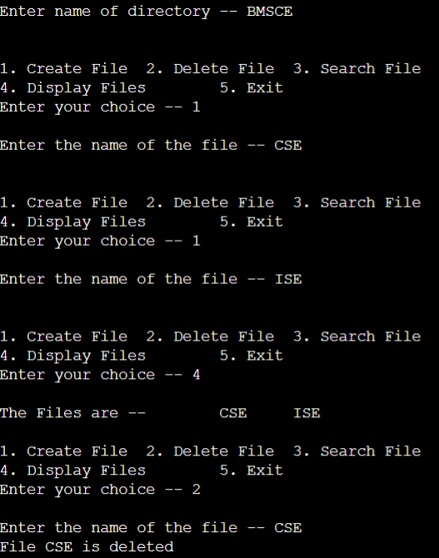

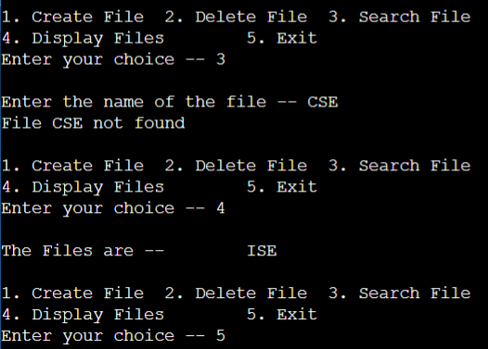

1. **Two Level Directory:**

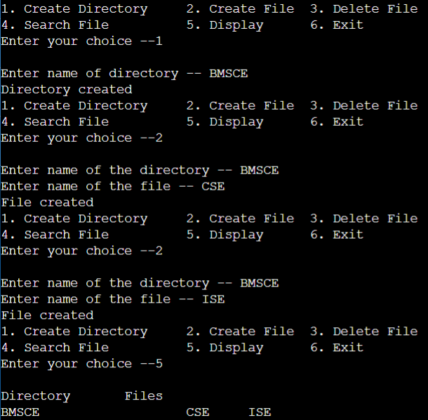

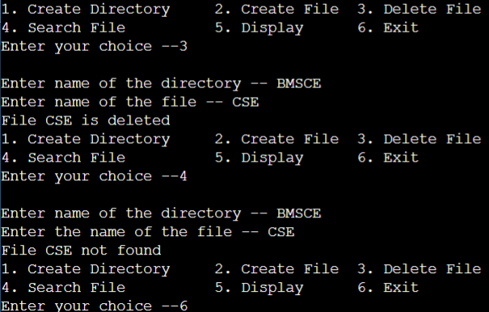

**Observation Book Pictures (File Organization Techniques):**

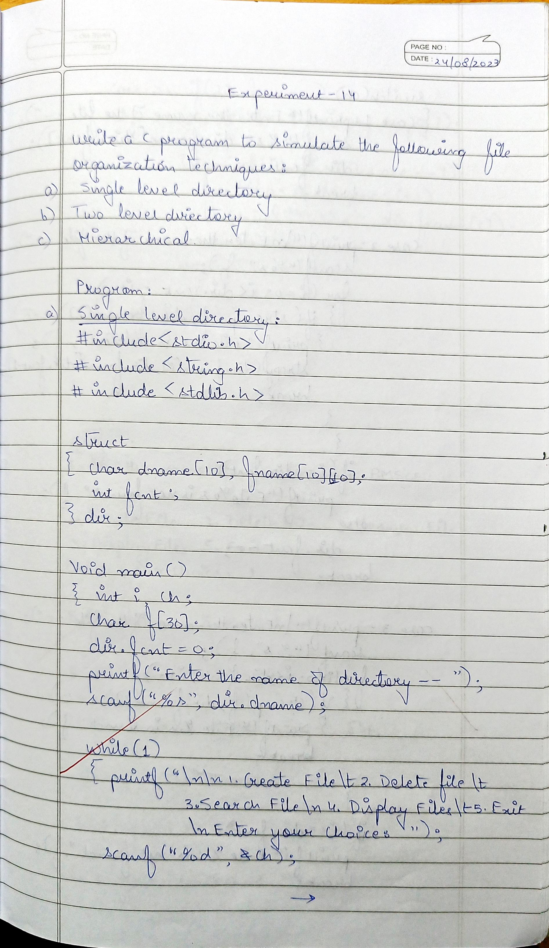

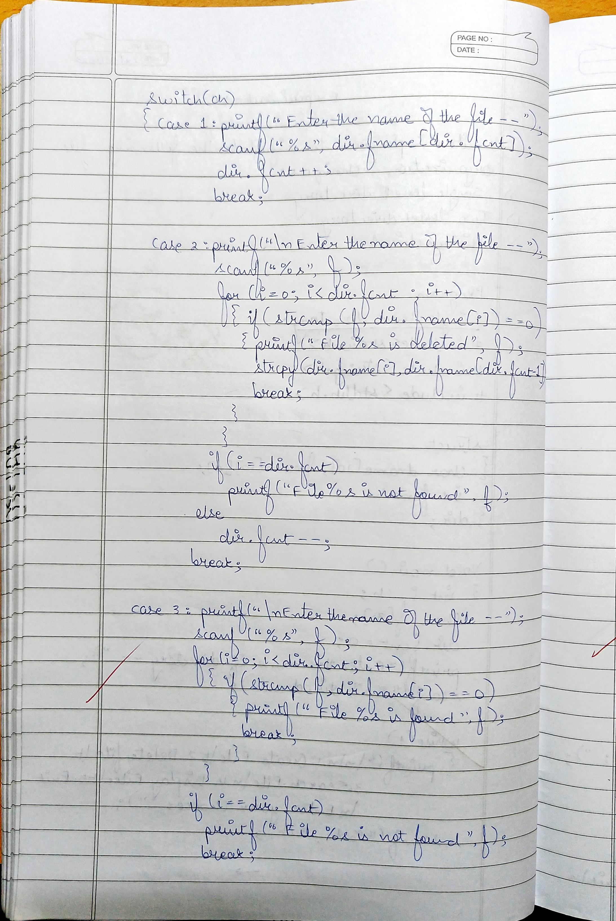

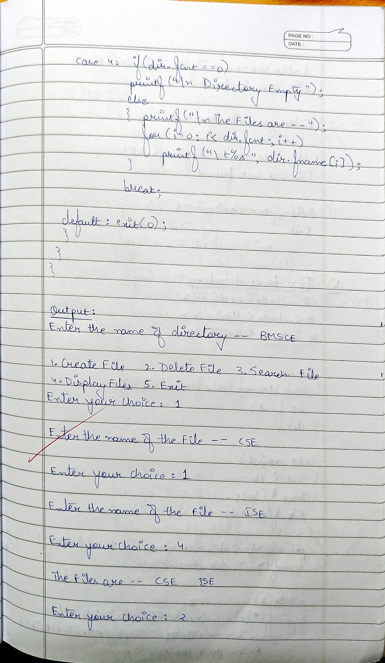

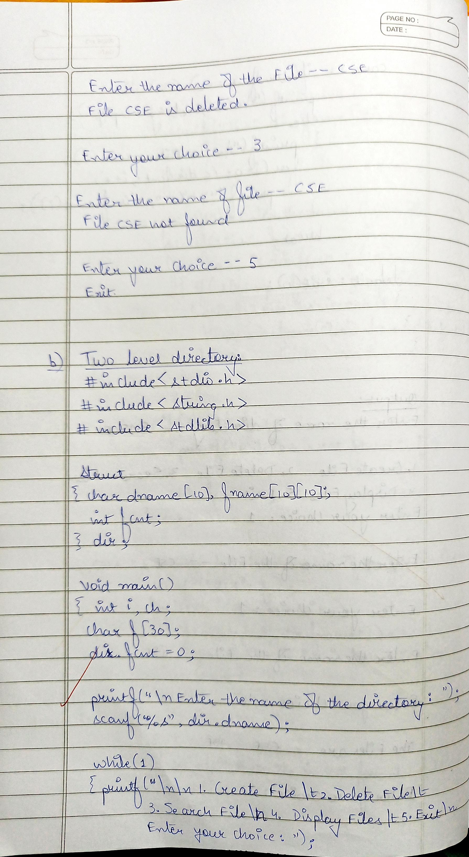

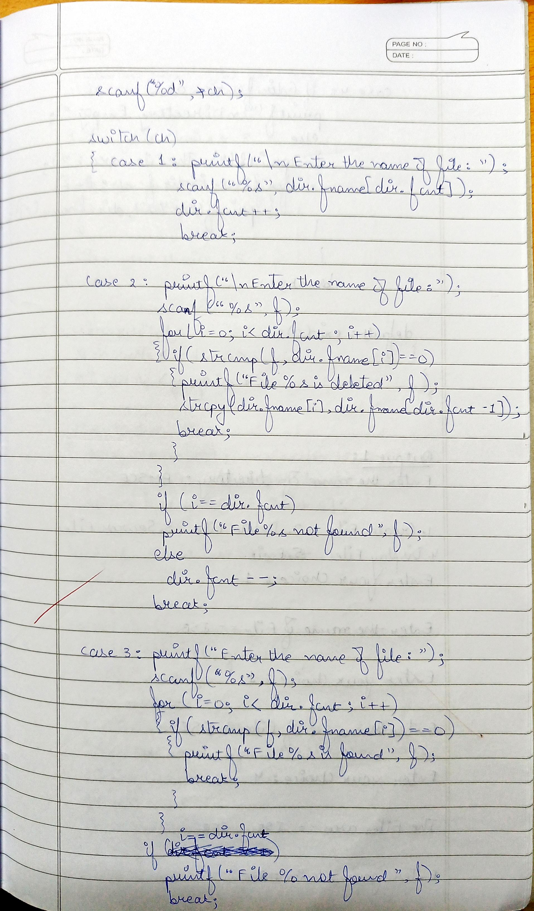

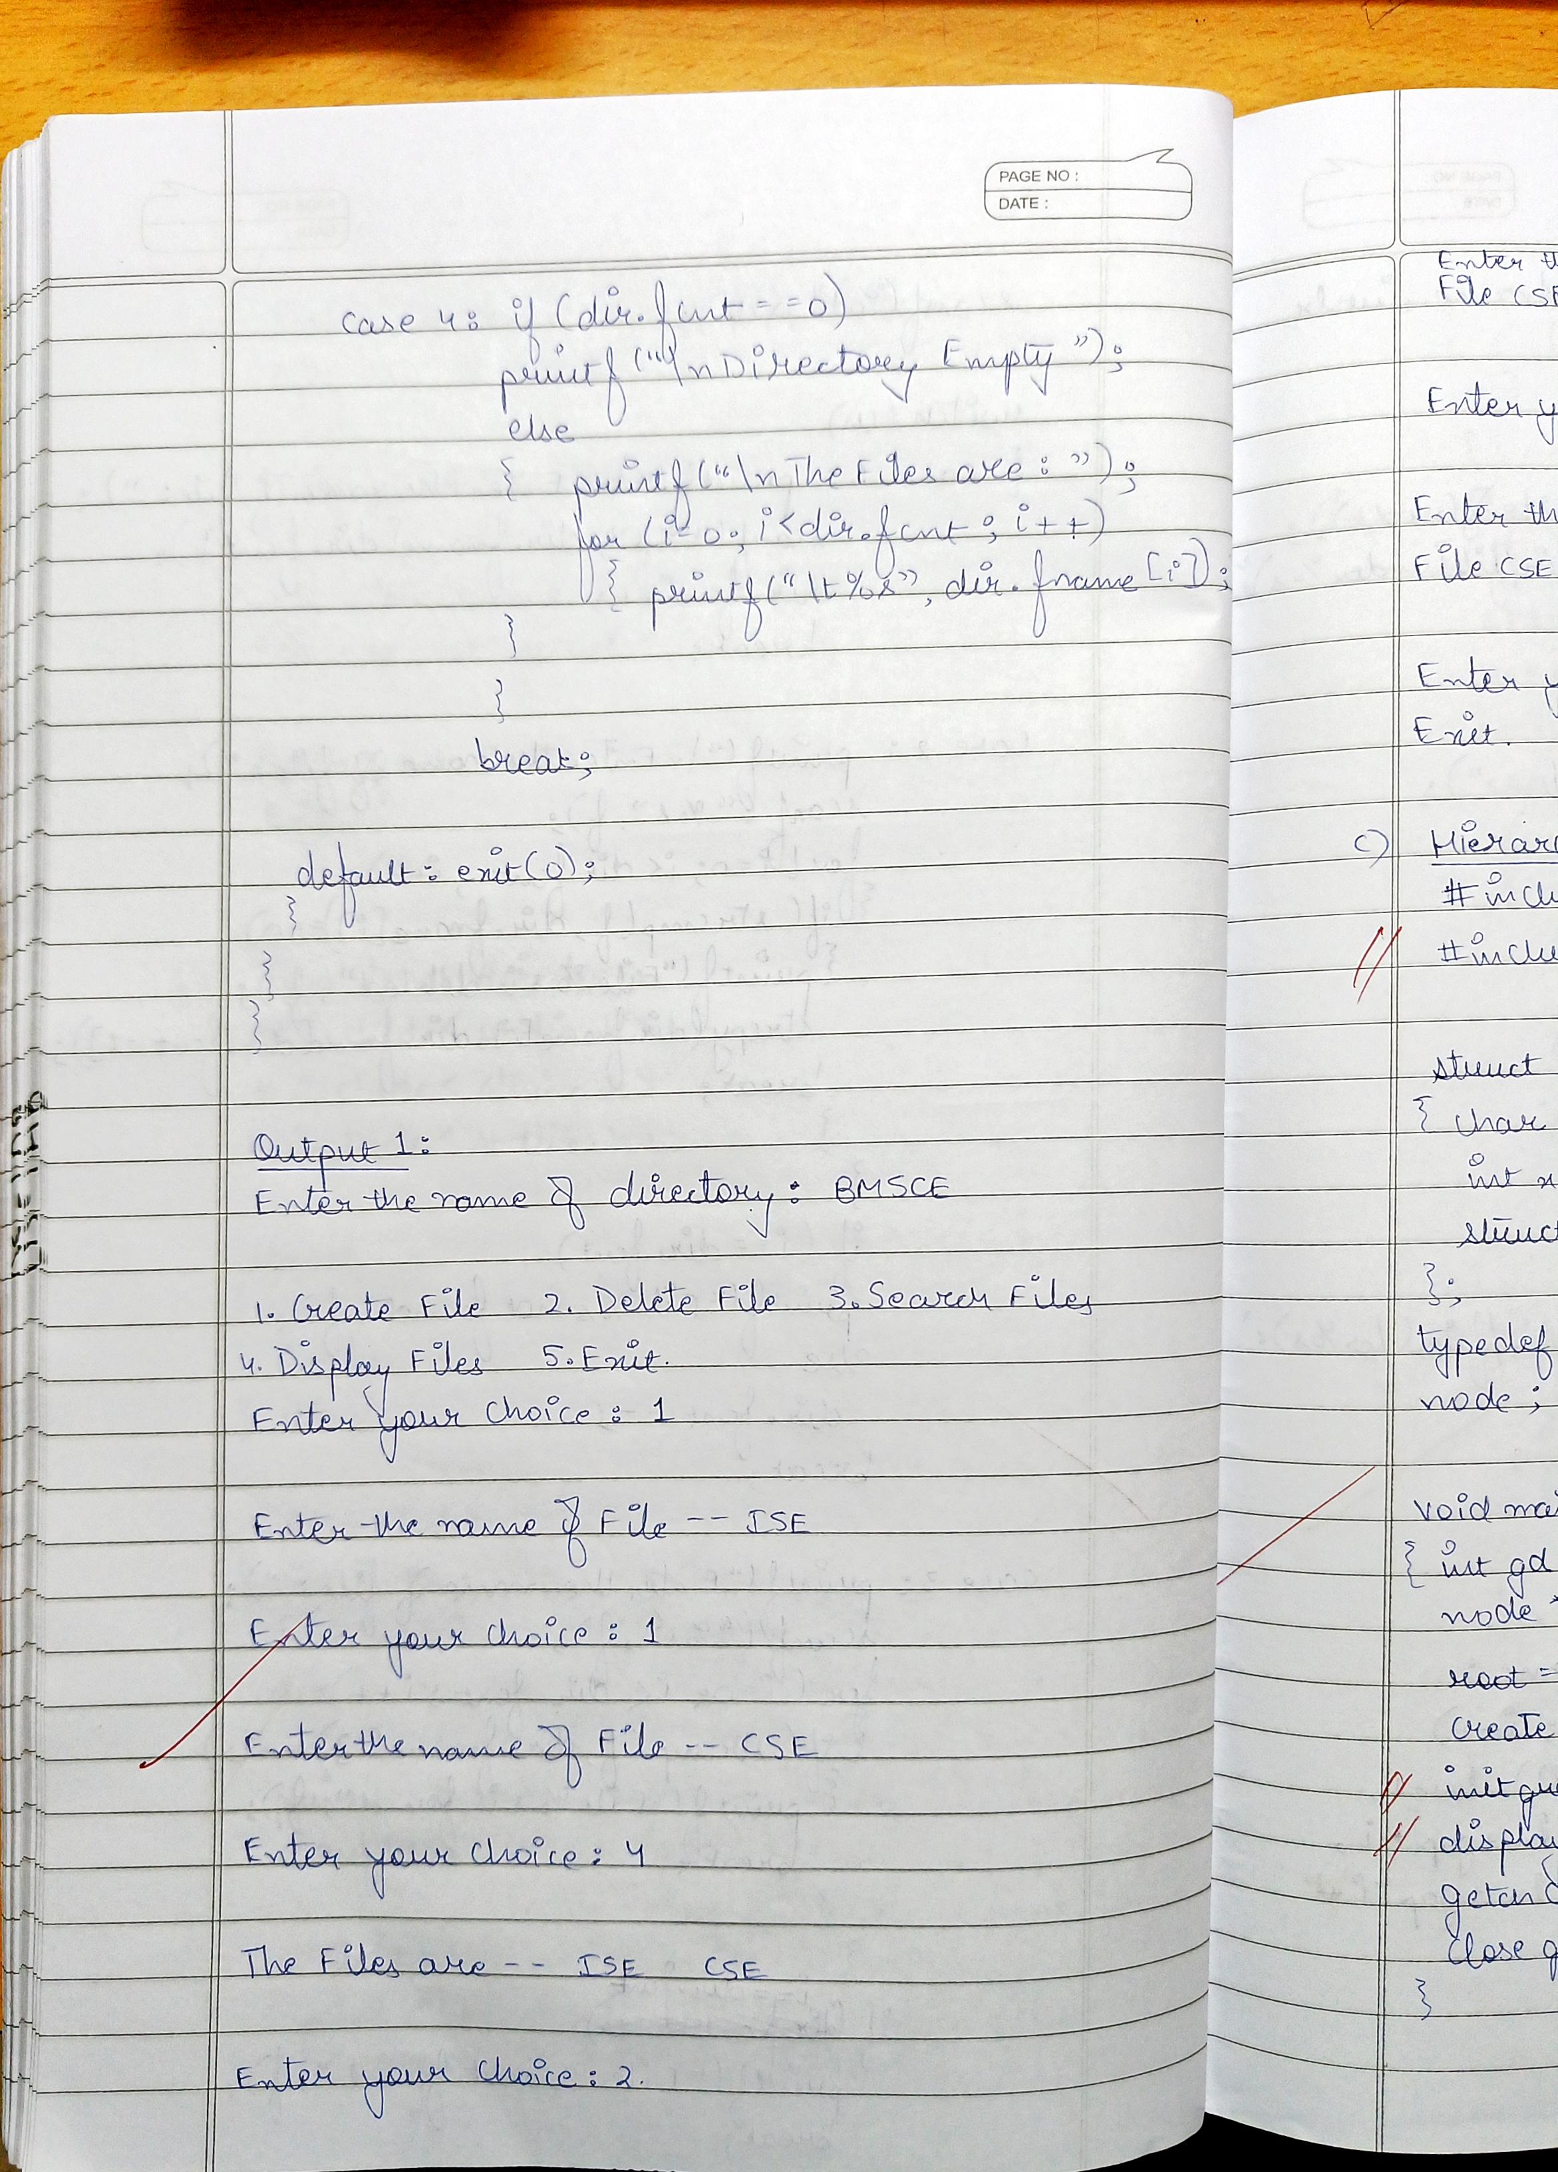

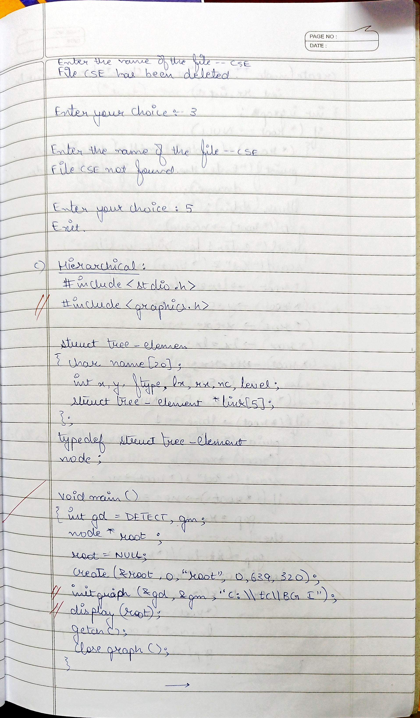

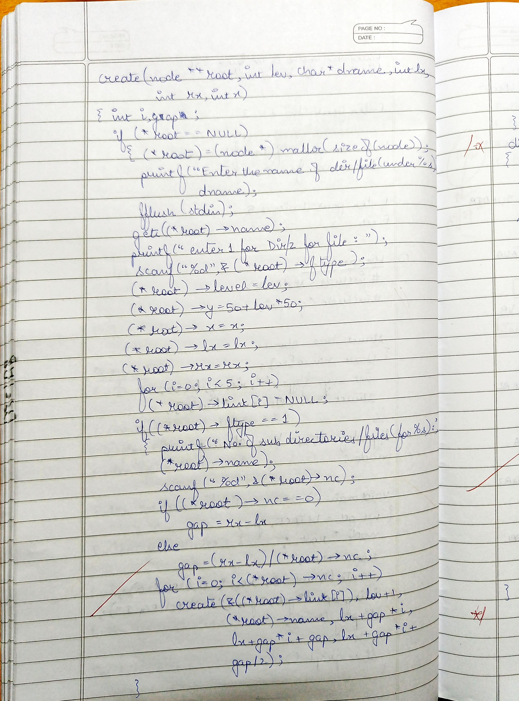



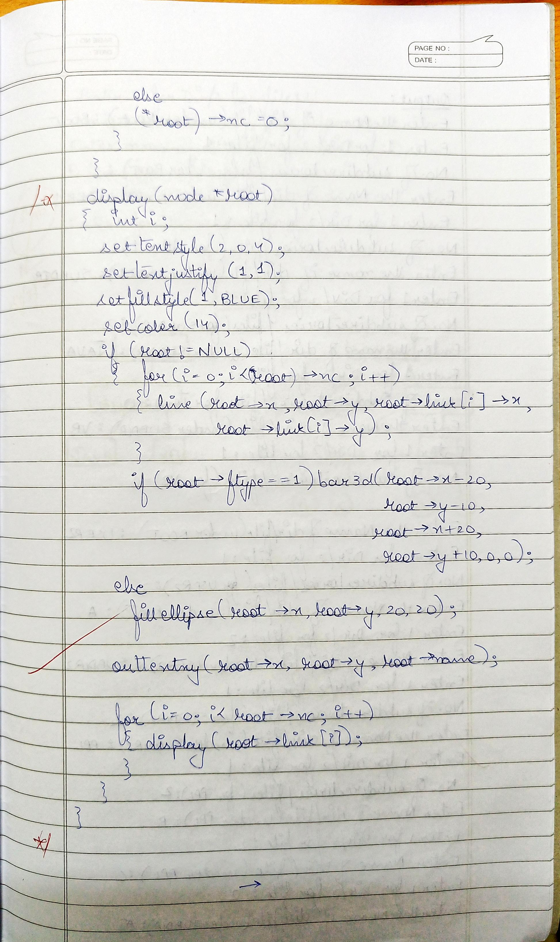

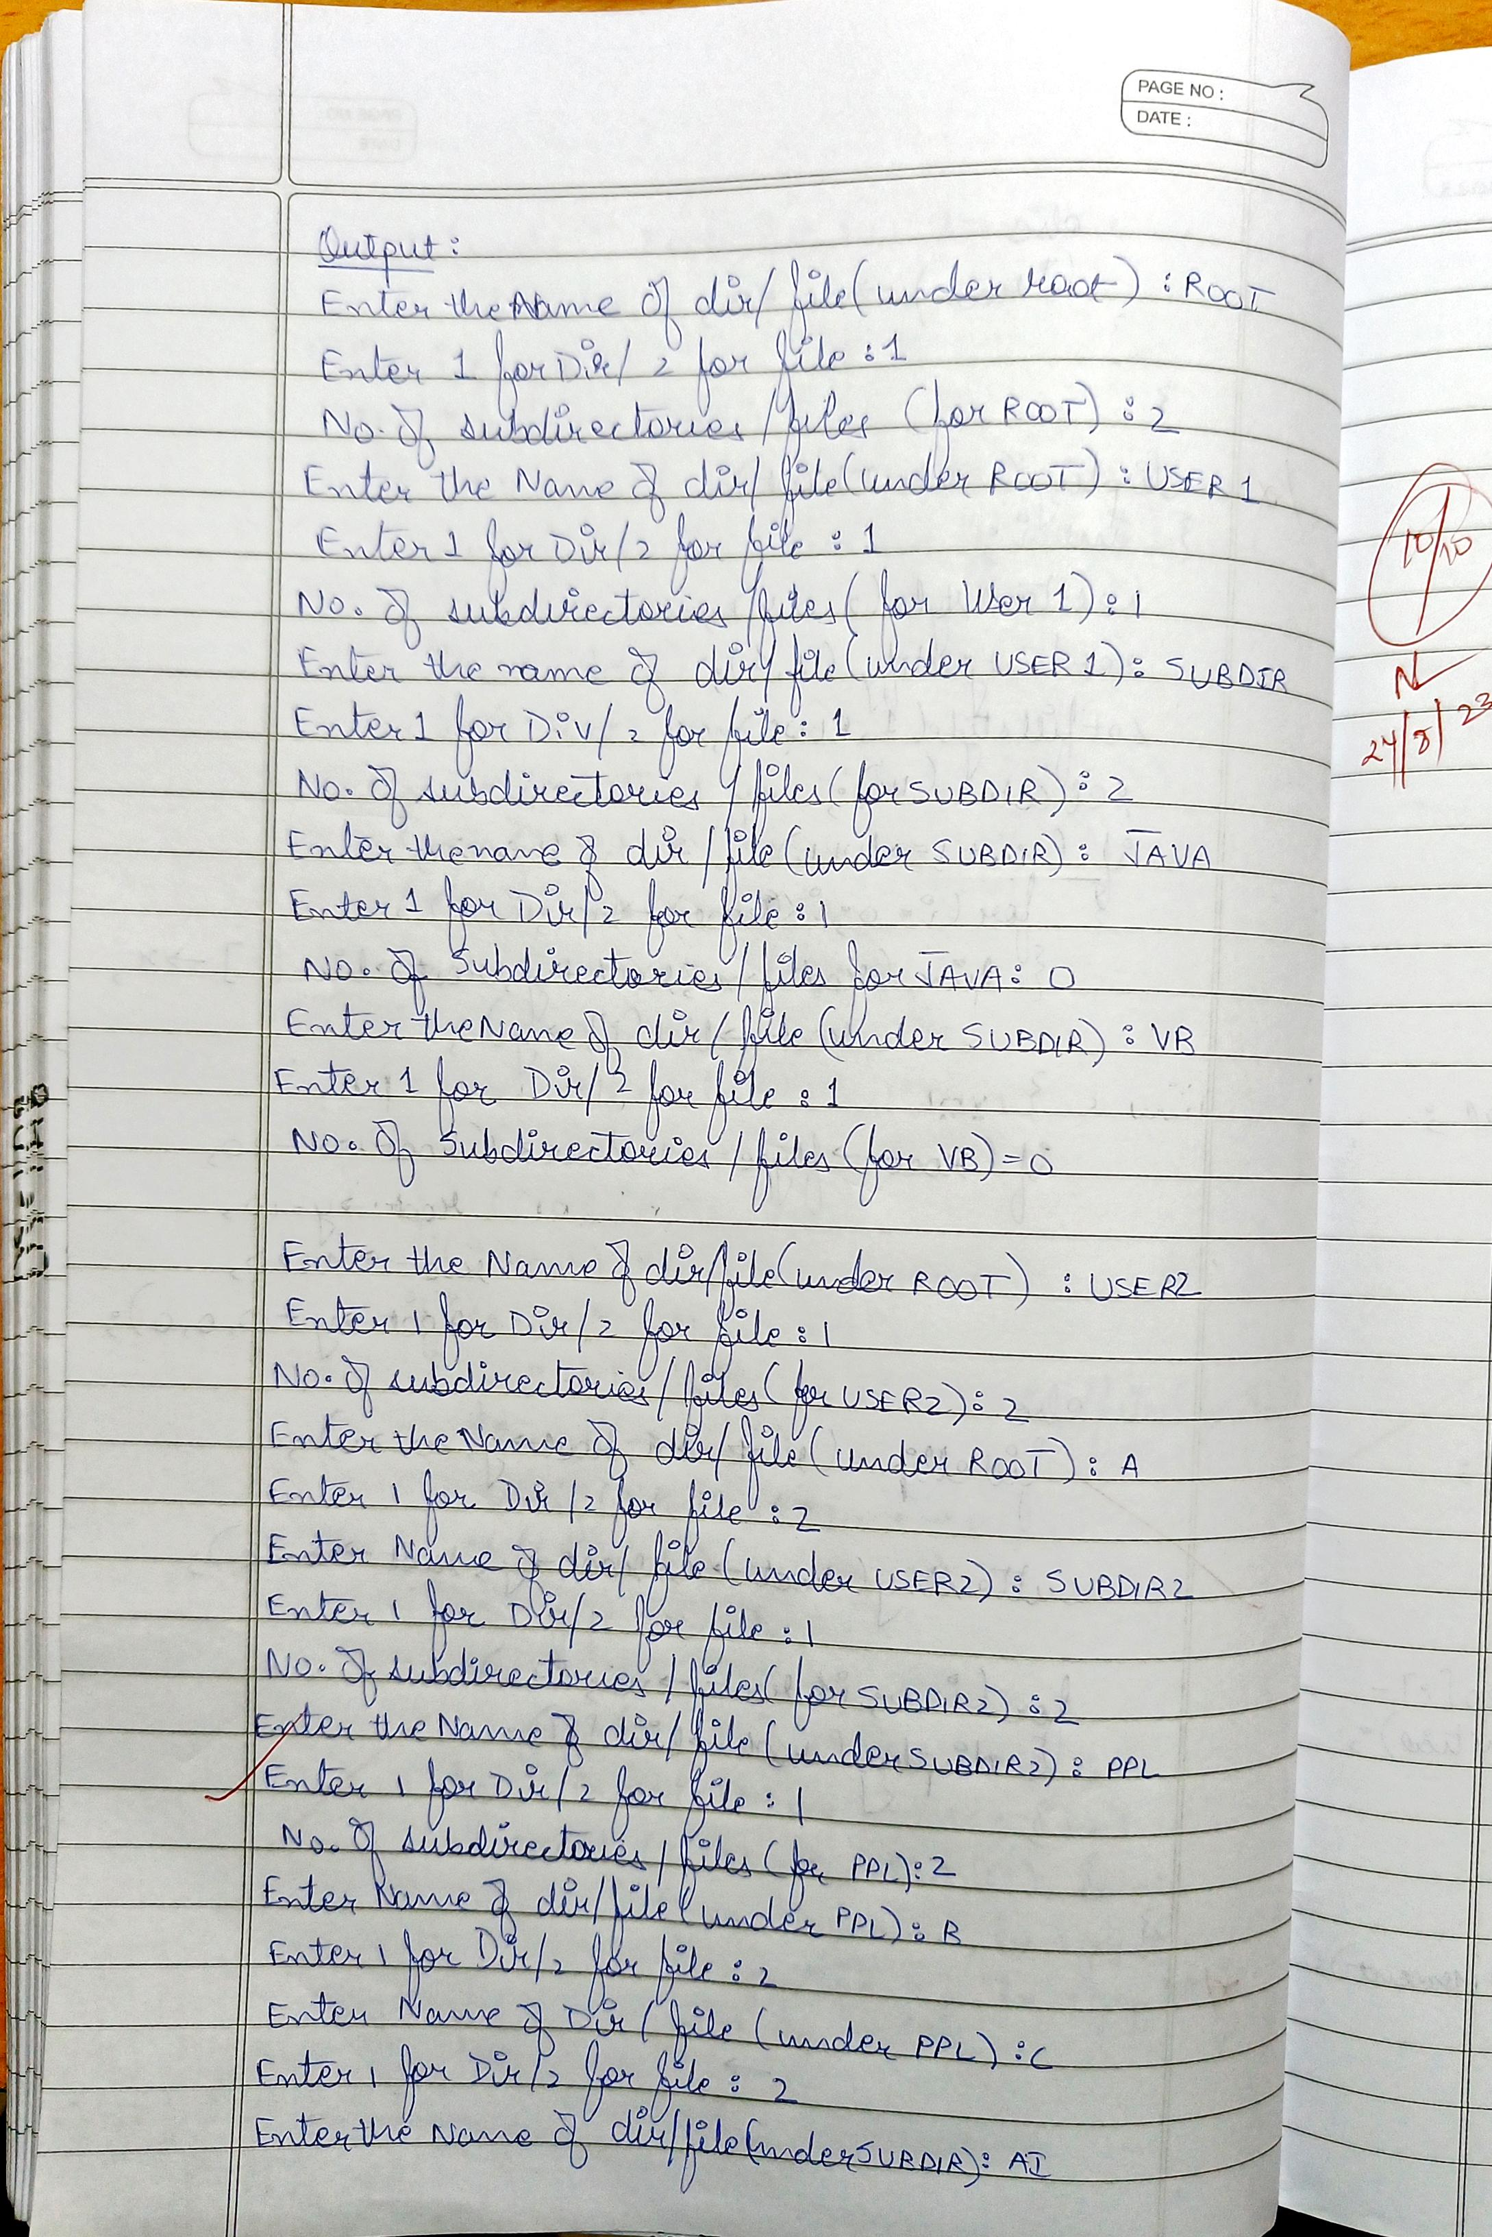

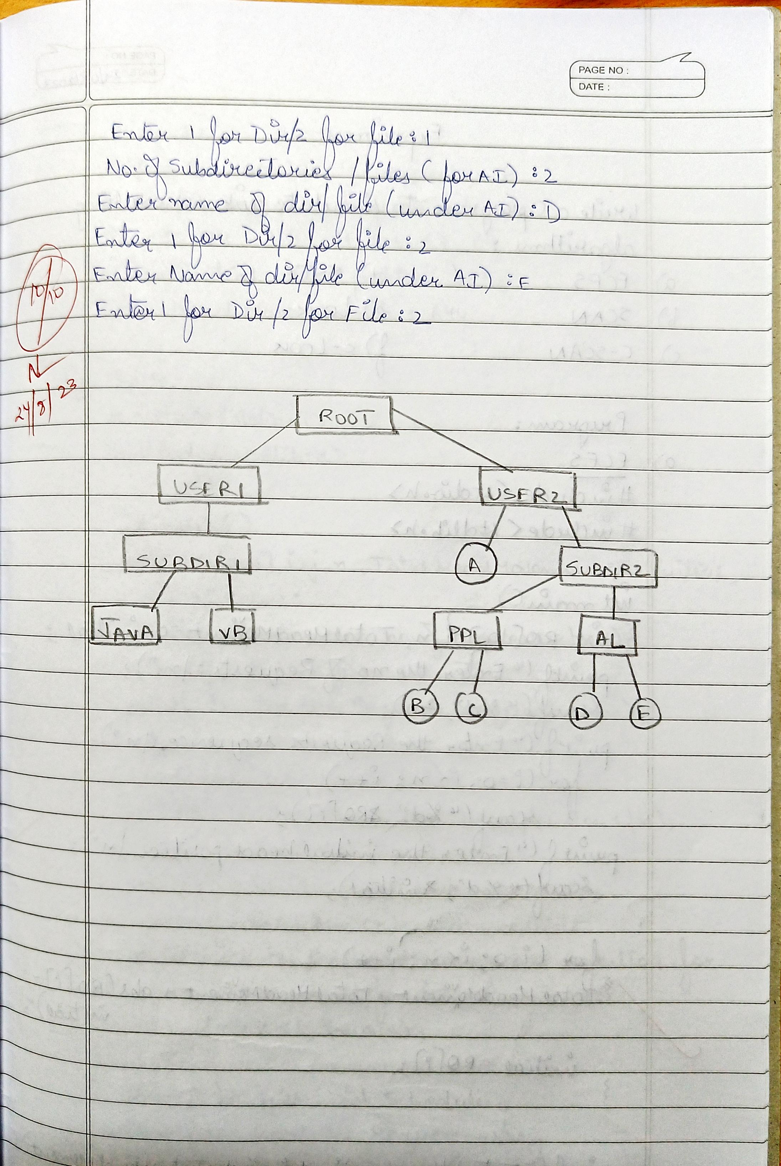

1. **Disk Scheduling Algorithms:**
2. **FCFS:**

#include<stdio.h>

#include<stdlib.h>

int main()

{

int RQ[100],i,n,TotalHeadMoment=0,initial;

printf("Enter the number of Requests\n");

scanf("%d",&n);

printf("Enter the Requests sequence\n");

for(i=0;i<n;i++)

scanf("%d",&RQ[i]);

printf("Enter initial head position\n");

scanf("%d",&initial);

// logic for FCFS disk scheduling

for(i=0;i<n;i++)

{

TotalHeadMoment=TotalHeadMoment+abs(RQ[i]-initial);

initial=RQ[i];

}

printf("Total head moment is %d",TotalHeadMoment);

return 0;

}

1. **SCAN:**

#include<stdio.h>

#include<stdlib.h>

int main()

{

int RQ[100],i,j,n,TotalHeadMoment=0,initial,size,move;

printf("Enter the number of Requests\n");

scanf("%d",&n);

printf("Enter the Requests sequence\n");

for(i=0;i<n;i++)

scanf("%d",&RQ[i]);

printf("Enter initial head position\n");

scanf("%d",&initial);

printf("Enter total disk size\n");

scanf("%d",&size);

printf("Enter the head movement direction for high 1 and for low 0\n");

scanf("%d",&move);

// logic for Scan disk scheduling

/*logic for sort the request array */

for(i=0;i<n;i++)

{

for(j=0;j<n-i-1;j++)

{

if(RQ[j]>RQ[j+1])

{

int temp;

temp=RQ[j];

RQ[j]=RQ[j+1];

RQ[j+1]=temp;

}

}

}

int index;

for(i=0;i<n;i++)

{

if(initial<RQ[i])

{

index=i;

break;

}

}

// if movement is towards high value

if(move==1)

{

for(i=index;i<n;i++)

{

TotalHeadMoment=TotalHeadMoment+abs(RQ[i]-initial);

initial=RQ[i];

}

// last movement for max size

TotalHeadMoment=TotalHeadMoment+abs(size-RQ[i-1]-1);

initial = size-1;

for(i=index-1;i>=0;i--)

{

TotalHeadMoment=TotalHeadMoment+abs(RQ[i]-initial);

initial=RQ[i];

}

}

// if movement is towards low value

else

{

for(i=index-1;i>=0;i--)

{

TotalHeadMoment=TotalHeadMoment+abs(RQ[i]-initial);

initial=RQ[i];

}

// last movement for min size

TotalHeadMoment=TotalHeadMoment+abs(RQ[i+1]-0);

initial =0;

for(i=index;i<n;i++)

{

TotalHeadMoment=TotalHeadMoment+abs(RQ[i]-initial);

initial=RQ[i];

}

}

printf("Total head movement is %d",TotalHeadMoment);

return 0;

}

1. **c-SCAN:**

#include<stdio.h>

#include<stdlib.h>

int main()

{

int RQ[100],i,j,n,TotalHeadMoment=0,initial,size,move;

printf("Enter the number of Requests\n");

scanf("%d",&n);

printf("Enter the Requests sequence\n");

for(i=0;i<n;i++)

scanf("%d",&RQ[i]);

printf("Enter initial head position\n");

scanf("%d",&initial);

printf("Enter total disk size\n");

scanf("%d",&size);

printf("Enter the head movement direction for high 1 and for low 0\n");

scanf("%d",&move);

// logic for C-Scan disk scheduling

/*logic for sort the request array */

for(i=0;i<n;i++)

{

for( j=0;j<n-i-1;j++)

{

if(RQ[j]>RQ[j+1])

{

int temp;

temp=RQ[j];

RQ[j]=RQ[j+1];

RQ[j+1]=temp;

}

}

}

int index;

for(i=0;i<n;i++)

{

if(initial<RQ[i])

{

index=i;

break;

}

}

// if movement is towards high value

if(move==1)

{

for(i=index;i<n;i++)

{

TotalHeadMoment=TotalHeadMoment+abs(RQ[i]-initial);

initial=RQ[i];

}

// last movement for max size

TotalHeadMoment=TotalHeadMoment+abs(size-RQ[i-1]-1);

/*movement max to min disk */

TotalHeadMoment=TotalHeadMoment+abs(size-1-0);

initial=0;

for( i=0;i<index;i++)

{

TotalHeadMoment=TotalHeadMoment+abs(RQ[i]-initial);

initial=RQ[i];

}

}

// if movement is towards low value

else

{

for(i=index-1;i>=0;i--)

{

TotalHeadMoment=TotalHeadMoment+abs(RQ[i]-initial);

initial=RQ[i];

}

// last movement for min size

TotalHeadMoment=TotalHeadMoment+abs(RQ[i+1]-0);

/*movement min to max disk */

TotalHeadMoment=TotalHeadMoment+abs(size-1-0);

initial =size-1;

for(i=n-1;i>=index;i--)

{

TotalHeadMoment=TotalHeadMoment+abs(RQ[i]-initial);

initial=RQ[i];

}

}

printf("Total head movement is %d",TotalHeadMoment);

return 0;

}

**Output (Disk Scheduling Algorithms):**

1. **FCFS:**

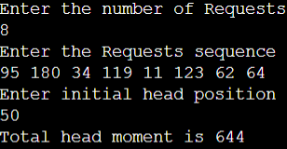

1. **SCAN:**

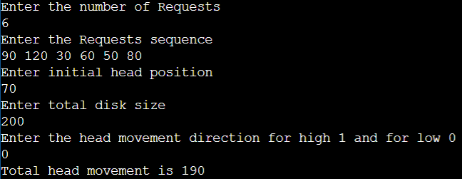

1. **C-SCAN:**

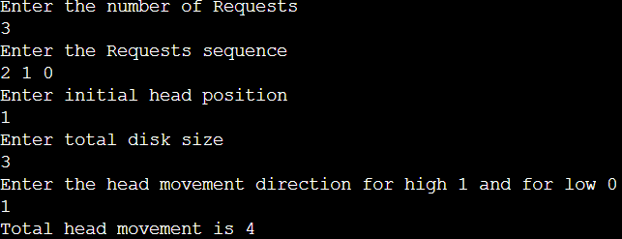

**Observation Book Pictures (Disk Scheduling Algorithms):**

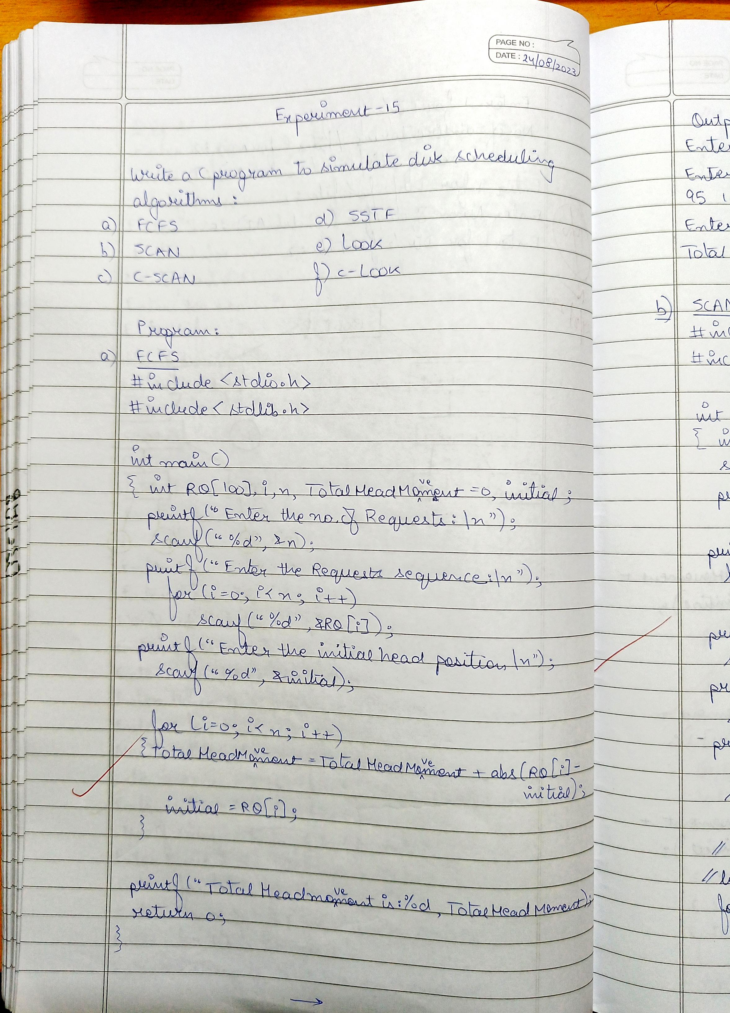

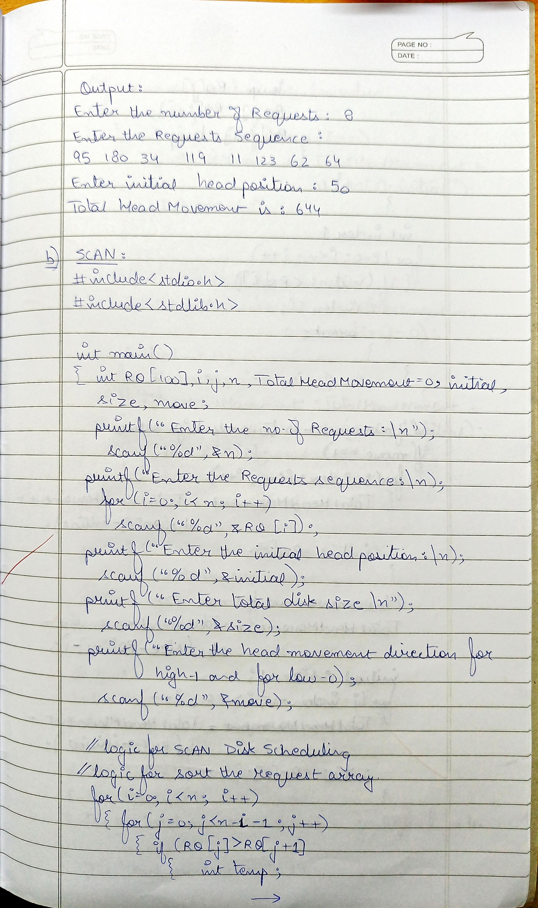

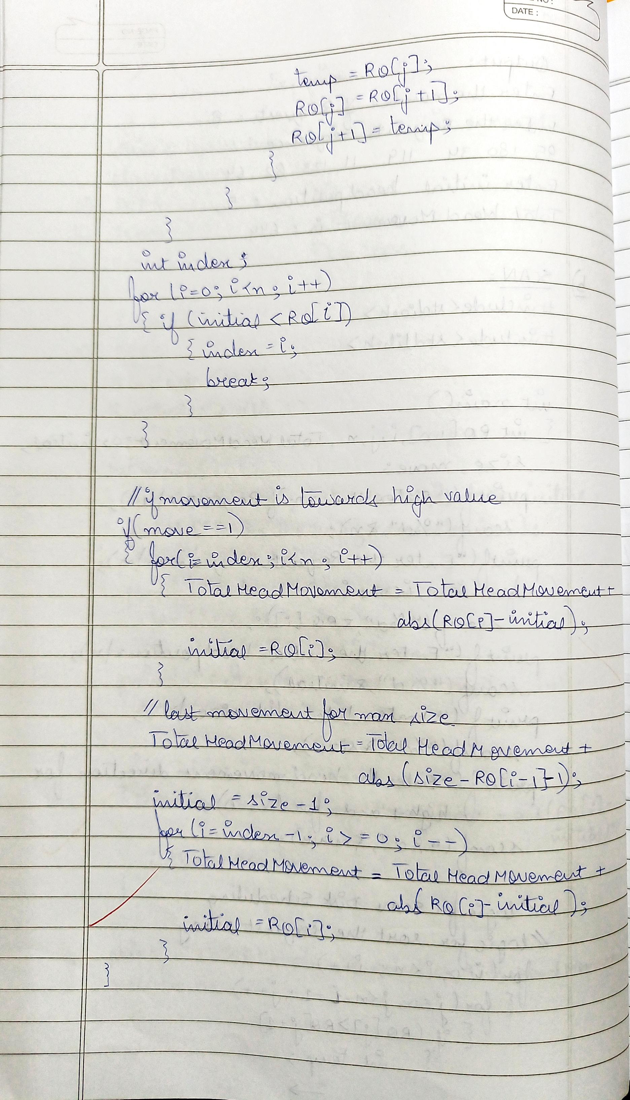

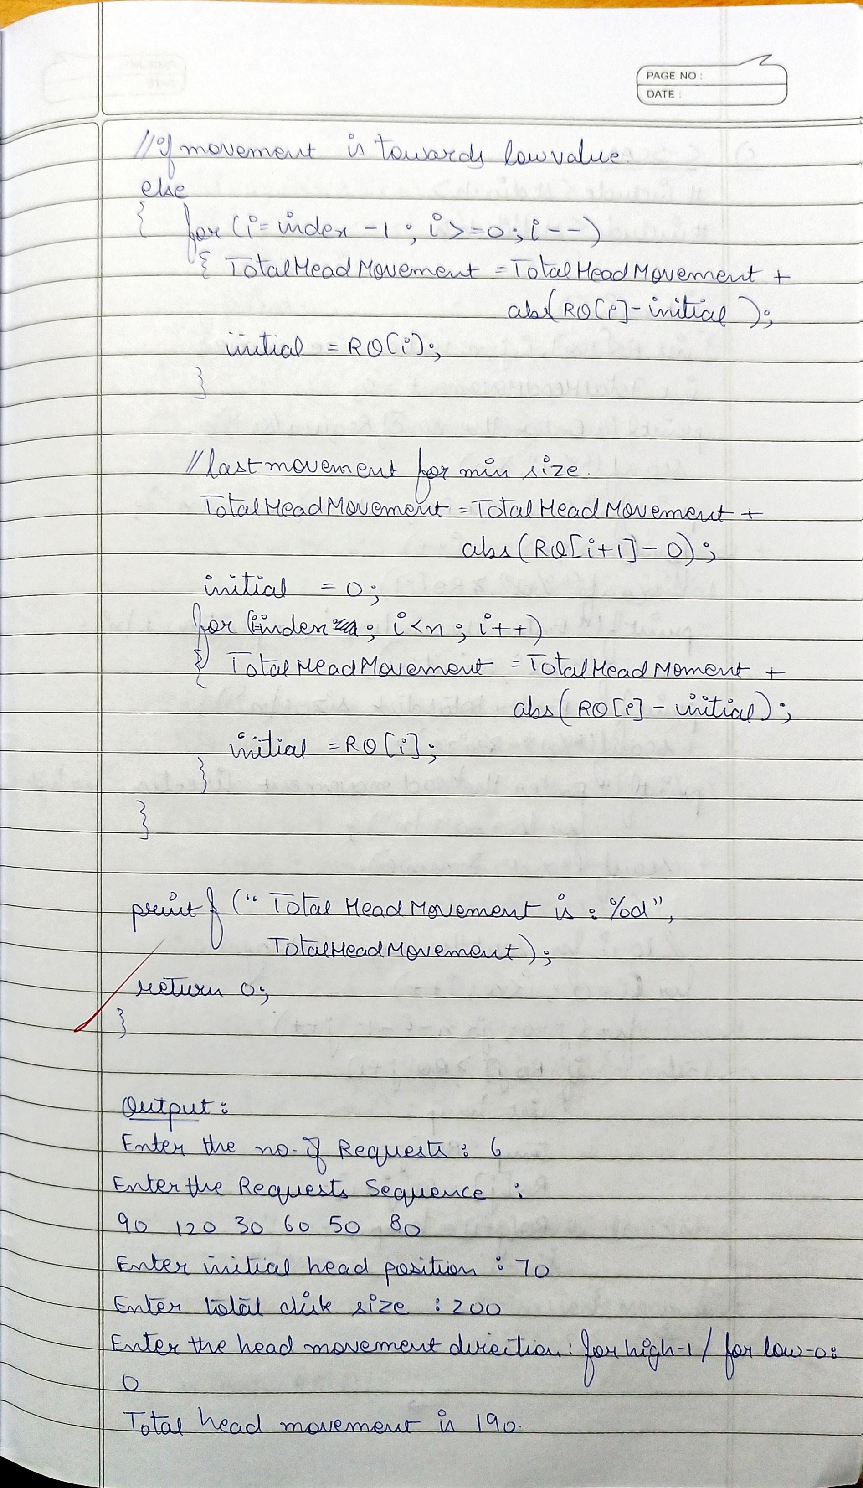

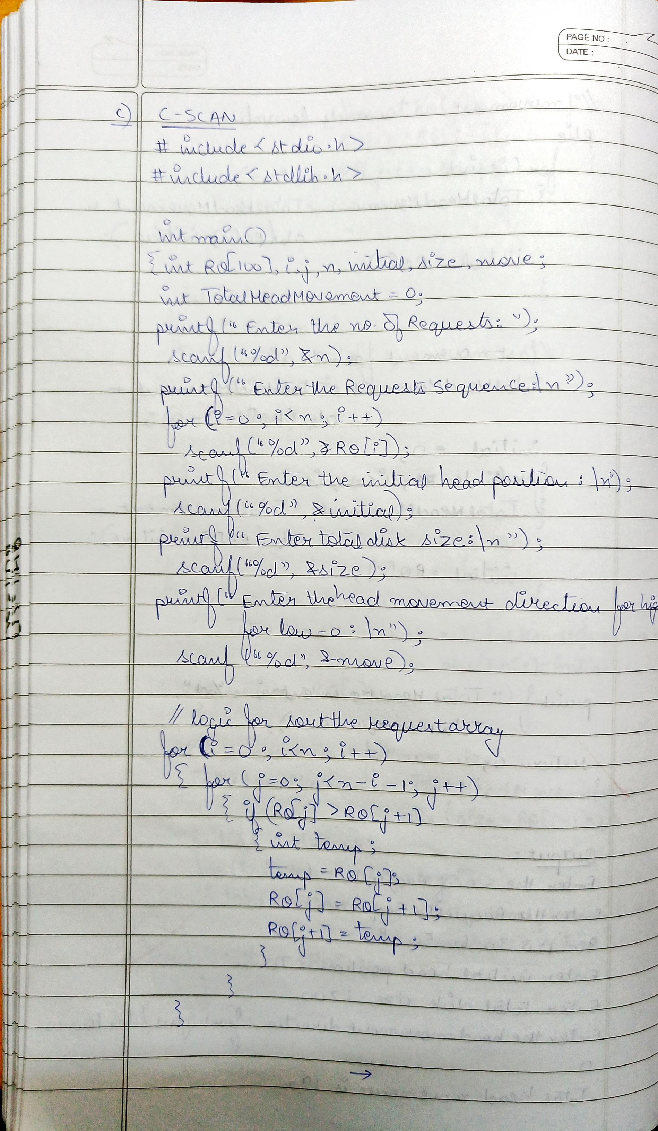

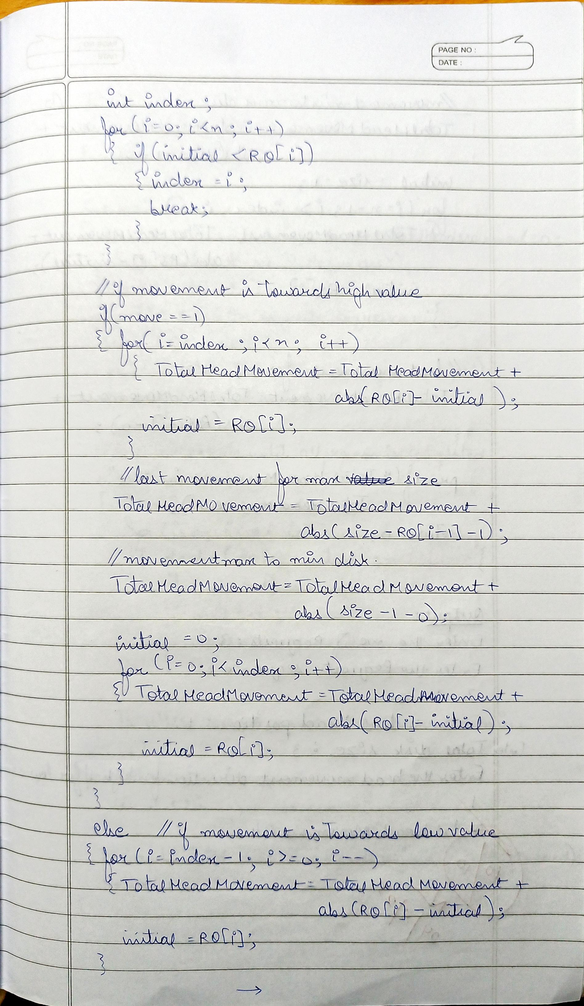

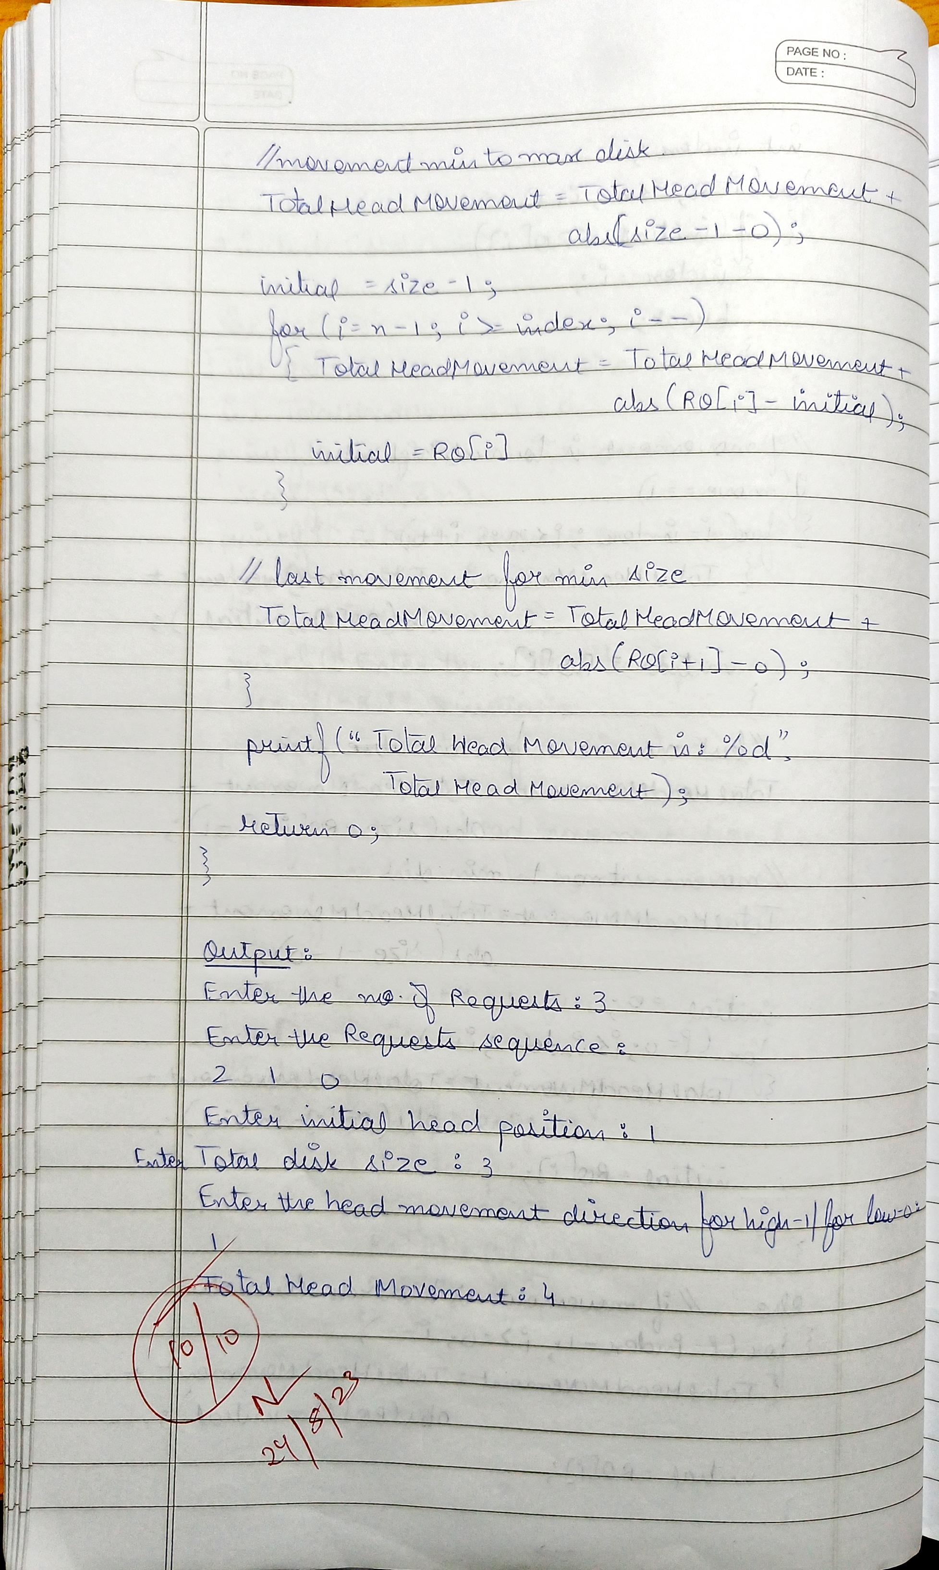

1. **Disk Scheduling Algorithms:**
2. **SSTF:**

#include<stdio.h>

#include<stdlib.h>

int main()

{

int RQ[100],i,n,TotalHeadMoment=0,initial,count=0;

printf("Enter the number of Requests\n");

scanf("%d",&n);

printf("Enter the Requests sequence\n");

for(i=0;i<n;i++)

scanf("%d",&RQ[i]);

printf("Enter initial head position\n");

scanf("%d",&initial);

// logic for sstf disk scheduling

/* loop will execute until all process is completed*/

while(count!=n)

{

int min=1000,d,index;

for(i=0;i<n;i++)

{

d=abs(RQ[i]-initial);

if(min>d)

{

min=d;

index=i;

}

}

TotalHeadMoment=TotalHeadMoment+min;

initial=RQ[index];

// 1000 is for max

// you can use any number

RQ[index]=1000;

count++;

}

printf("Total head movement is %d",TotalHeadMoment);

return 0;

}

1. **LOOK:**

#include<stdio.h>

#include<stdlib.h>

int main()

{

int RQ[100],i,j,n,TotalHeadMoment=0,initial,size,move;

printf("Enter the number of Requests\n");

scanf("%d",&n);

printf("Enter the Requests sequence\n");

for(i=0;i<n;i++)

scanf("%d",&RQ[i]);

printf("Enter initial head position\n");

scanf("%d",&initial);

printf("Enter total disk size\n");

scanf("%d",&size);

printf("Enter the head movement direction for high 1 and for low 0\n");

scanf("%d",&move);

// logic for look disk scheduling

/*logic for sort the request array */

for(i=0;i<n;i++)

{

for(j=0;j<n-i-1;j++)

{

if(RQ[j]>RQ[j+1])

{

int temp;

temp=RQ[j];

RQ[j]=RQ[j+1];

RQ[j+1]=temp;

}

}

}

int index;

for(i=0;i<n;i++)

{

if(initial<RQ[i])

{

index=i;

break;

}

}

// if movement is towards high value

if(move==1)

{

for(i=index;i<n;i++)

{

TotalHeadMoment=TotalHeadMoment+abs(RQ[i]-initial);

initial=RQ[i];

}

for(i=index-1;i>=0;i--)

{

TotalHeadMoment=TotalHeadMoment+abs(RQ[i]-initial);

initial=RQ[i];

}

}

// if movement is towards low value

else

{

for(i=index-1;i>=0;i--)

{

TotalHeadMoment=TotalHeadMoment+abs(RQ[i]-initial);

initial=RQ[i];

}

for(i=index;i<n;i++)

{

TotalHeadMoment=TotalHeadMoment+abs(RQ[i]-initial);

initial=RQ[i];

}

}

printf("Total head movement is %d",TotalHeadMoment);

return 0;

}

1. **c-LOOK:**

#include<stdio.h>

#include<stdlib.h>

int main()

{

int RQ[100],i,j,n,TotalHeadMoment=0,initial,size,move;

printf("Enter the number of Requests\n");

scanf("%d",&n);

printf("Enter the Requests sequence\n");

for(i=0;i<n;i++)

scanf("%d",&RQ[i]);

printf("Enter initial head position\n");

scanf("%d",&initial);

printf("Enter total disk size\n");

scanf("%d",&size);

printf("Enter the head movement direction for high 1 and for low 0\n");

scanf("%d",&move);

// logic for C-look disk scheduling

/*logic for sort the request array */

for(i=0;i<n;i++)

{

for( j=0;j<n-i-1;j++)

{

if(RQ[j]>RQ[j+1])

{

int temp;

temp=RQ[j];

RQ[j]=RQ[j+1];

RQ[j+1]=temp;

}

}

}

int index;

for(i=0;i<n;i++)

{

if(initial<RQ[i])

{

index=i;

break;

}

}

// if movement is towards high value

if(move==1)

{

for(i=index;i<n;i++)

{

TotalHeadMoment=TotalHeadMoment+abs(RQ[i]-initial);

initial=RQ[i];

}

for( i=0;i<index;i++)

{

TotalHeadMoment=TotalHeadMoment+abs(RQ[i]-initial);

initial=RQ[i];

}

}

// if movement is towards low value

else

{

for(i=index-1;i>=0;i--)

{

TotalHeadMoment=TotalHeadMoment+abs(RQ[i]-initial);

initial=RQ[i];

}

for(i=n-1;i>=index;i--)

{

TotalHeadMoment=TotalHeadMoment+abs(RQ[i]-initial);

initial=RQ[i];

}

}

printf("Total head movement is %d",TotalHeadMoment);

return 0;

}

**Output (Disk Scheduling Algorithms):**

1. **SSTF:**

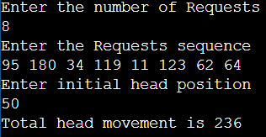

1. **LOOK:**

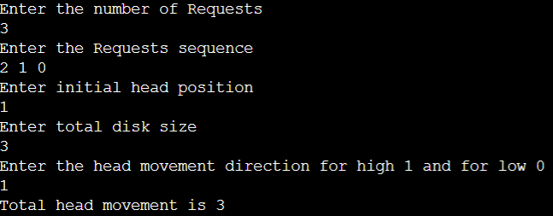

1. **c-LOOK:**

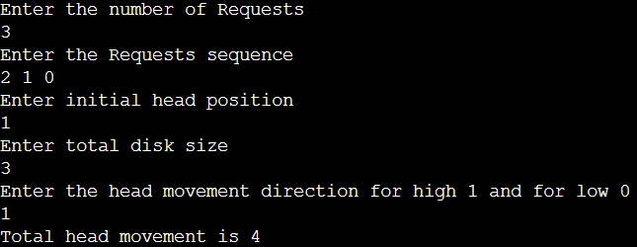

**Observation Book Pictures (Disk Scheduling Algorithms):**

